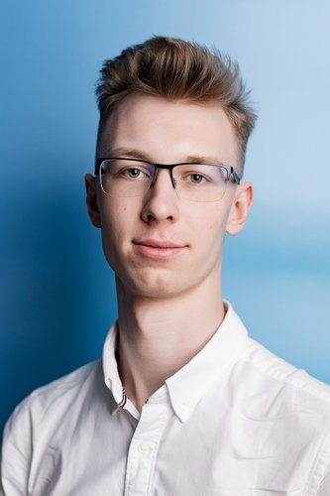 | Sorokin Andrey Anatolievich  Male, 20 years, born on 26 July 2002  +7 (911) 2335692  asorokin2002@gmail.com — preferred means of communication  Reside in: Saint Petersburg  Citizenship: Russia, work permit at: Russia  Ready to relocate: USA, Canada, ready for business trips
Desired position and salary
Software Engineer/Developer
Specializations:
— Programmer, developer

Employment: part time, full time
Work schedule: remote working, flexible schedule
travel time to work: any
Education
Higher
2024 | Санкт-Петербургский национальный исследовательский университет информационных технологий, механики и оптики, Санкт-Петербург  Факультет интернет-программирования и технологий, Информационные системы и технологии
Key skills
Languages | Russian — Native  English — C1 — Advanced
Skills | Обучаемость Коммуникабельность Лидерские качества Целеустремл Быстрое принятие решений Стремление делать качественно Грамотная речь Организаторские навыки Умение работать в команде Управленческие навыки Ведение переговоров Деловое общение Работа в команде Деловая переписка Английский язык Управление проектами Деловая коммуникация Руководство коллективом
Additional information
About me | Hard skills (IT):  - Back-end:  - - C++ (MSA)  - - C# (OOP principles, frameworks: ASP.NET CORE, WPF, WF, Entity)  - - Java (OOP principles, frameworks: Spring)  - Front-end:  - - JavaScript (Vue.js)  - - Typescript  - - CSS  - - HTML  - DataBases (writing scripts of queries):  - - T-SQL  - - MySQL  - - SparQL  - - RDF Data Expert  - Analytics:  - - SQL  - - Tableu  - - Python (for data proccesing)  - Tools:  - - Git  - - Github  - - MarkDown  - - Docker  - - Azure  Soft skills:  - Communication, teambuilding, responsibility, diligence, punctuality  - trying to develop projects, self-development  - Languages - Russian, English (Upper-intermediate)  Achievements (at university):  - Admin of group (1st course)  - Olimpiad volunteer (organization and technical support, 1st course)  - National team - MMA (since 1st course and right now)  Lifestyle:  - Location - Saint-Petersburg  - Age - 20  - Studying - ITMO University  - Sport -  - - In young years: Sports ballroom dancing, Baseball (proff.)  - - In junior years: Ice hockey  - - In adult years: MMA  - Hobbies -  - - musician: (instruments: paino, guitar), singer, writing songs  - - Self-development: reading books and articles (exactly a lot)  - - Other interests: business area, financial literacy, investments, time-managment

